Name
Institution
Course

a). An isoquant is defined as a locus or curve of all possible combination of inputs like labour and capital (L K) in production of same value of output. It is based on assumption that, inputs are substituted constantly with the process of production.
Output let’s say Q represent Output
Q=Min(x _{1,} x_{2/} 4)
Therefore, X₁= Q and X₂ =4Q
Our isoquant will be along X₂=4x₁
Q=2, 3, 7
The diagram below shows the isoquants for producing two quads, three quads and seven quads.
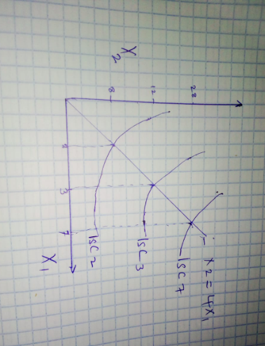
b). we have input demand for frame, as X₁=Q, X₂=4Q
Note: input demand frame does not depend on the price of inputs
If x2 =12, then it follows that, Q=min(x_{1,} 12/4)
=min (x₁, 3)
So quantity is maximized at 3
Therefore we can say MP₁ ₌ Change in Q/ change in x₁
X₁<3, and thus change in Q/Change in X₁ ₌1,
Now MP of adding an additional frame becomes 1 (one)
c). Firm cost function is a function that factors in prices of inputs and quantity of output in a farm and whose value represents the cost of coming up with an output based on the input prices. The concepts of cost function is applied by use utilization of curve cost by firms when minimizing the cost in the attempt to maximize efficiency production.
Cost Function is given by C=W₁X₁ +W₂X₁
C=P₁Q+ P₂ (4Q)
C= Q (P₁+4P₂)
Now P1=10
P2 =4
Q=7
C = 7 (16+10)
= £182 is the cost of producing 7 squads
d). Assume that the firm needs to pay £50 per day
Assume each wheel costs £4 and each frame costs £10
Suppose that the firm can only produce 10quads per day and the rent
Therefore
FC=50
Q=10
PQ=30
It follows that, C=10(10+16) = £260
Now the total revenue will be given by P.Q -TC-FC + PROFIT
PQ is 30x10=300
300-260- 50 =-10
This implies that all variable cost are at (£260) and are being recovered from production. So the firm is in production in short run. The firm should not produce since the price at which it can sell quads is less than what it should have gotten. It is undesirable for the firms to sell products below their production cost. Sometimes, companies resorts to this policy of selling below production cost. However, turnover may be very low and as such, big losses are incurred hence distorting the market. In such case, once the firm reduced prices of its outputs it becomes a challenge to get back to its previous status. Further, in case of the firm producing sales are affected as well as future pricing (Money matters all management articles 2020).
e). Now the rent is avoidable and profit is at (10) which is a loss. This means that, the firm is not supposed to get involved in production process today. This reason behind this is that there is loss occurring from the production and thus it need to be avoided. This particular firm is likely to experience a challenge in future pricing in case it move forward and produce because it will sell at a loss. In regard to price determination, it will be difficult to enjoy discretion as far as setting price is concerned. In fact it will be faced with a dilemma on whether to price its price above or below production cost. With this understanding I think the firm should make a wise decision before producing and setting price for its product in regard to its production cost (Money matters all management articles 2020).

References

Money matters all management articles (2020) .Selling below cost of production. Reason market condition. https://accountlearning.com/selling-below-cost-of-production-reason-market-conditions/#

